**Exercise 1: Mocking and Stubbing**

**CODE:**

public interface ExternalApi {

String getData();

}

public class MyService {

private ExternalApi api;

public MyService(ExternalApi api) {

this.api = api;

}

public String fetchData() {

return api.getData();

}

}

import static org.mockito.Mockito.*;

import static org.junit.jupiter.api.Assertions.*;

import org.junit.jupiter.api.Test;

import org.mockito.Mockito;

public class MyServiceTest {

@Test

public void testExternalApi() {

ExternalApi mockApi = Mockito.mock(ExternalApi.class);

when(mockApi.getData()).thenReturn("Mock Data");

MyService service = new MyService(mockApi);

String result = service.fetchData();

assertEquals("Mock Data", result);

}

}

**OUTPUT:**

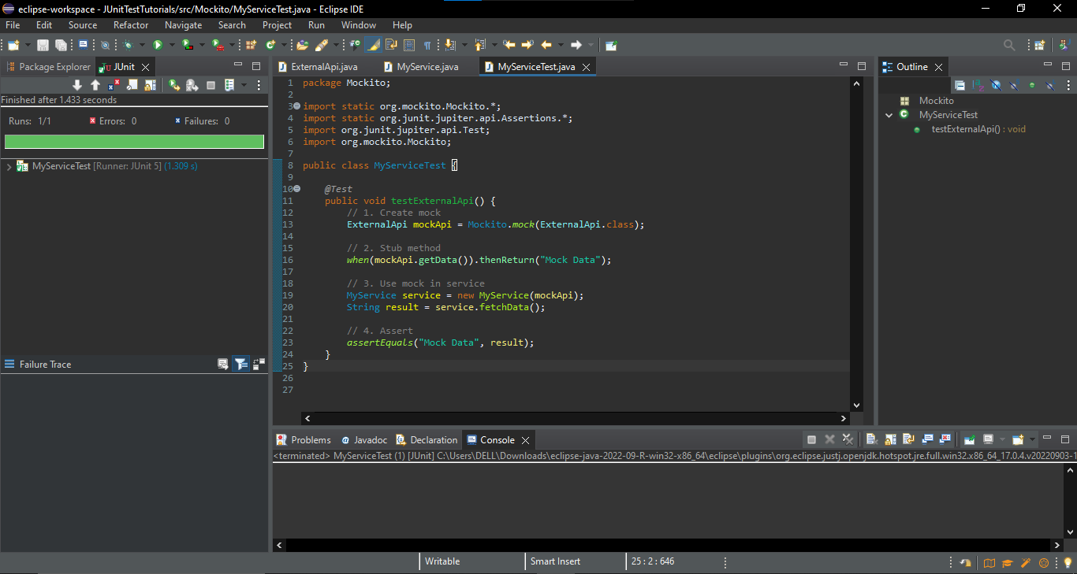

**Exercise 2: Verifying Interactions**

**CODE:**

public interface ExternalApi {

String getData();

}

public class MyService {

private ExternalApi api;

public MyService(ExternalApi api) {

this.api = api;

}

public String fetchData() {

return api.getData();

}

}

import static org.mockito.Mockito.*;

import org.junit.jupiter.api.Test;

import org.mockito.Mockito;

public class MyServiceTestVerifiation {

@Test

public void testVerifyInteraction() {

ExternalApi mockApi = Mockito.mock(ExternalApi.class);

MyService service = new MyService(mockApi);

service.fetchData(); // Internally calls mockApi.getData()

verify(mockApi).getData(); // This line checks if mockApi.getData() was called

}

}

**OUTPUT:**

